**X Alignment Mix3D Example Problem**

This example problem has an angio material where all of the fibers are oriented in the same direction. This file differs from “XAlignment” in that the linear rotation method (Mix3D) is used to determine the new growth direction rather than the linear interpolation method.

**Geometry**

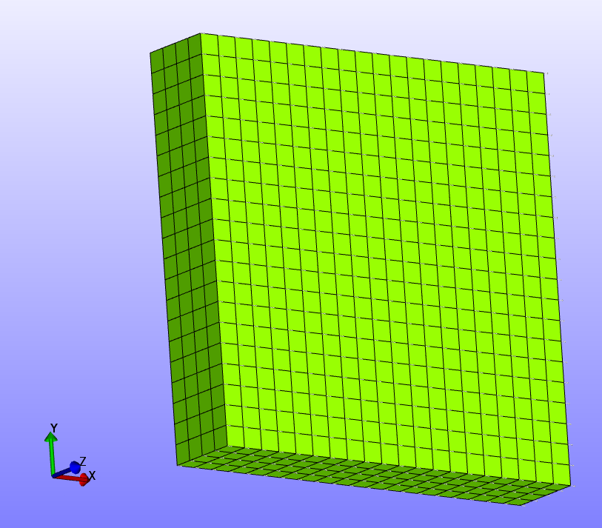

**Boundary Conditions**

-Z face fixed in z.

-Y face fixed in y.

-X face fixed in x.

All fibers are oriented in +x direction.

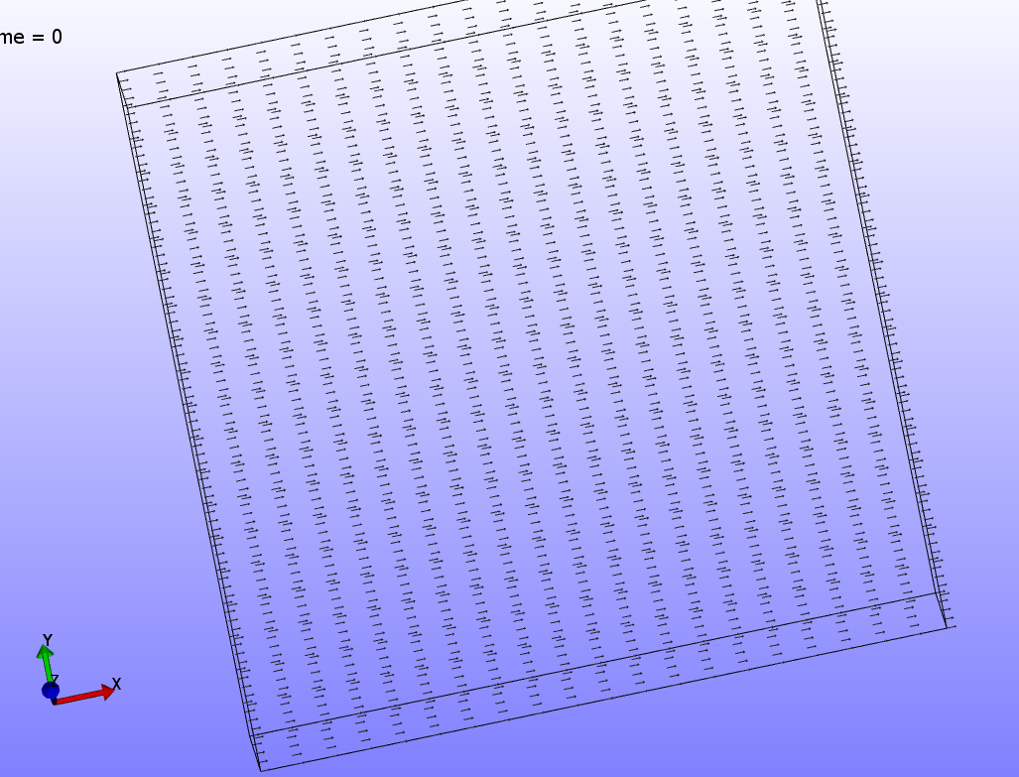

A visualization of the fibers used in this model.

**Material(s)**

The material used in this model is an angio material.

**Results**

Vessel growth is directed by all of the fiber being oriented in the +x direction.

